Texas Style Turkey chili

INGREDIENTS
- 2 lbs. Ground Turkey
- 1 tsp Bolner’s Fiesta Brand® Onion Powder
- ¼ cup Diced Red Bell Pepper
- 1 cup Mexican Corn
- 2 Tbs Diced Green Chilis
- 1 ½ cans Tomato Sauce (8 oz can)
- 4 Tbs Bolner’s Fiesta Brand® Fancy Light Chili Powder
- 1 Tbs Bolner’s Fiesta Brand® Ground Comino
- 2 tsp Bolner’s Fiesta Brand® Granulated Garlic
- 1 ½ cup Chicken Broth (14 oz can) (Add additional broth or water as needed)
- Optional for our Northern Chili Lovers:
  - 1 can (15 oz) Ranch Style Beans, drained and rinsed

DIRECTIONS
- Cook turkey as specified on the package. Always cook to well-done, 165°F as measured by a meat thermometer.
- Bring broth and tomatoes to a boil. Add other ingredients and let boil for 10 minutes. Decrease heat and simmer for 30 minutes.

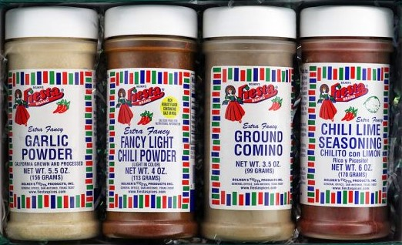

https://www.fiestaspices.com/product/traditional-mexican/

